

East of England ODN   
Study Day Booking Form

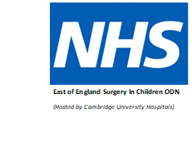

|  |  |
| --- | --- |
| Study day title / date |  |
| Name |  |
| Job Title & Band/Grade |  |
| Trust |  |
| Email |  |

**This booking form can be used to book any of the following events:**

Surgical Study day – Thursday 28th April & Thursday 20th September

**Please indicate which event *and* date you are booking below**

The electronic version can be obtained from your lead nurse / PDN. Please email completed booking form to add-tr.eoesicodn@nhs.net

Your place will be confirmed on receipt of application and no later than 2 weeks prior to the event.

East of England Paediatric Critical Care ODN

*(Hosted by Cambridge University Hospitals)*

