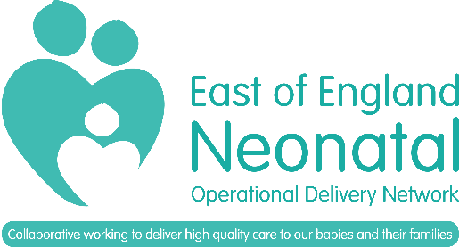
EOE Neonatal ODN Study Day Funding 2023
Application Form
If you are successful you will be expected to write a short article for the ODN newsletter
To apply: Please fill this form in on your computer and email to kelly.hart5@nhs.net

Name
Job Title
Current Neonatal Unit
NHS E-mail
Name of course/study day
Please provide the date if applicable

Have you applied for funding from another source (e.g. unit/charity funds). If so please specify in the box below.
In no more than 200 words please tell us why we should fund this, how it will benefit the network and how you plan to share your learning.

