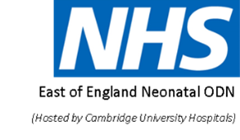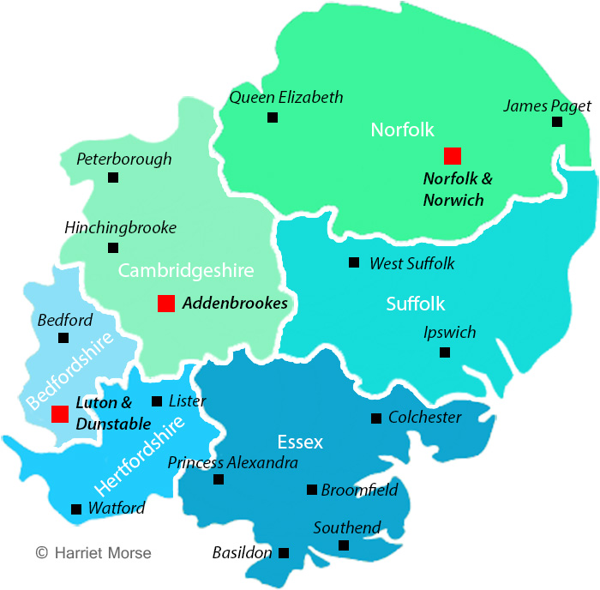

East of England Regional Maternity Team

Incident Reporting Communication Document: <27-week delivery in a centre without a NICU. (updated July 2021)

*PLEASE NOTE: This exception form should be completed and submitted and copies emailed to Neonatal ODN kelly.hart5@nhs.net and polly.basak@nhs.net
Maternity Clinical network england.maternitycn@nhs.net and the relevant Local Maternity and Neonatal system:
Bedford, Luton & Milton Keynes (Bedfordshire Hospitals Trust – Bedford & Luton sites, Milton Keynes) : blmkccg.blmk-lms@nhs.net & Hemasutton@nhs.net
Cambridge & Peterborough (North West Anglia & Cambridge): CAPCCG.ChildrenAndMaternity@nhs.net
Herts & West Essex (East & North Herts, Princess Alexandra, West Herts): Michelle Braithwatie m.wells.braithwaite@nhs.net & Jacki.dopran1@nhs.net
Mid & South Essex (Basildon, Mid Essex, Southend) : meccg.localmaternityandneonatalsystem@nhs.net
Norfolk & Waveney (Queen Elizabeth, Kings Lynn, Norfolk & Norwich, James Paget) : nwccg.lmnsshared@nhs.net
Suffolk & NE Essex (East Suffolk & North Essex, West Suffolk):
Helen.bowles4@nhs.net

Maternity Unit Name: West Hertfordshire Hospital Trust. Watford Hospital.

Infant details including Badgernet Number and Initials:  NHS: |  | Woman / Birthing person’s details including NHS number
Date / time of admission of Woman / Birthing person: |  | Date / time of Initial review:  Date/ Time of Obstetric review: |  | Date/ Time of birth:
Gestation at Admission

Gestation at Birth

Mother’ ethnic origin |  |  | Father’ ethnic origin
Were efforts made to undertake an in- utero transfer prior to delivery?
If unsuccessful or not possible which of the following statements apply |  |  |  |  | Please tick
Tertiary NICU unable to accept.
Tertiary Obstetric service unable to accept.
Delivery occurred prior to transfer.
Maternal condition unsafe for transfer.
Delivery indicated immediately.
Woman / birthing person declined transfer (please give details of reason for decline).
BBA Outside of building

Other reasons:
Prior to delivery did communications take place with:
Tertiary centre NICU consultant
Senior Obstetrician of receiving unit
Senior Midwife on labour ward of the receiving unit
Senior Nurse of the receiving unit
If no, please give details why not:

Were there any risk factors for preterm birth identified during the pregnancy, or present but not identified at antenatal appointments. If yes was a referral to the preterm birth clinic made, in line with the Saving babies lives care bundle v2 and a personalised care plan in place?
Had the women contacted day assessment unit, triage, delivery suite her CMW or GP with any concerns or symptoms that suggest pre-term birth within the two weeks prior to admission?
To include, but not limited to:
Contractions
Abdominal pain
Backache
Urinary symptoms
Vaginal spotting or bleeding
Vaginal discharge- watery or offensive
If yes, what were they? please include who was contacted, the advice and plan of care and the role and grade of the member of staff giving the advice.

Has the event been reported as clinical incident within your Trust / reported via datix?
If yes, has it been reviewed locally, and any actions identified?

Please give details of learning points raised from the review (if a more detailed review will take place, please include immediate learning points below and update once full review undertaken):

Name / title of reviewer(s):

Incident Reported by:
Name and Title: | Date:
Organisation:

